PROPERTY MANAGEMENT APPLICATION USING SALESFORCE

Project Description:

Develop an App for the Property Management where Buyer can order his Requirements

and get the Appropriate Details of the Property. According to his interest just provide him with

some discounts upwhat extent he can get the discount. Also Track Whether he is Interested in

taking the loan available for so just calculate how much loan Amount user can get it. Provide the

Security for two different profiles like for marketing and sales team. Then Finally Create the

reports and dashboard so there will be clear view just get the reports on the count of loan passed

getting the property purchased close the deal.

What you'll learn

1. Real Time Salesforce Project

2. Object & Relationship in Salesforce

1.Introduction:

Real estate management software :

Real estate management is not a new concept. Property managers have been managing

relevant data for as long as the rental market has existed. However, as new technologies become

more widely available, the capabilities of real estate management are advancing. Today’s real

estate management software is used to connect property managers and tenants like never before.

That’s because modern real estate management tools incorporate the same technology used in

customer relationship management (CRM). With CRM for real estate management, property

managers can now offer their tenants the kind of high-level customer service that is so important

to developing long-term business relationships.

1.1 Overview :

Based on the GrandViewResearch study, the global property management software market size

is expected to reach $14 million by 2028. It means that more and more companies are going to

invest in residential and commercial real estate technology and CRM consulting. Learn what

companies look for in the property management CRM, why they choose Salesforce for property

management, and what top solutions are powered by this platform.

1.2.Purpose :

Salesforce Property Management has powerful tools to remain associated with clients and

tenants continuously, support further connections, track key data about business and residential

properties, including occupancy rates, essential tenants, and revenue and take your productivity,

and business growth, to the next…

Best Property Management CRM on Top of Salesforce.

Breal Real Asset Management CRM.

AgentHub Property Administration CRM.

Rethink Real Estate Administration CRM.

Property base CRM Property Rent Management CRM.

A property management system (PMS) is a software application for the operations of

hospitality accommodations and commercial residential rental properties. PMS is also used in

manufacturing industries, local government and manufacturing.

PMS provides a centralized computer system to organize, schedule and perform the day-

to- day functions and transactions involved in accommodations businesses. Computer record

keeping and PMS have increased the efficiency of hospitality industries significantly simply by

making it possible to update and consult centralized records from multiple computers and

devices. PMS solutions have been customized for the needs of the hospitality industry to further

increase ease of operations. Functions managed by a PMS include automation of many common

tasks, including:

• Bookings

• Check-in and check-out

Telephone systems integration

Point of sale (POS) integration

Event planning

Food and beverage costing

• Hotel inventory supply management

Reporting of key performance indicators (KPI)

2.PROBLEM DEFINATION & DESIGN THINKING

2.1 EMPATHY MAP

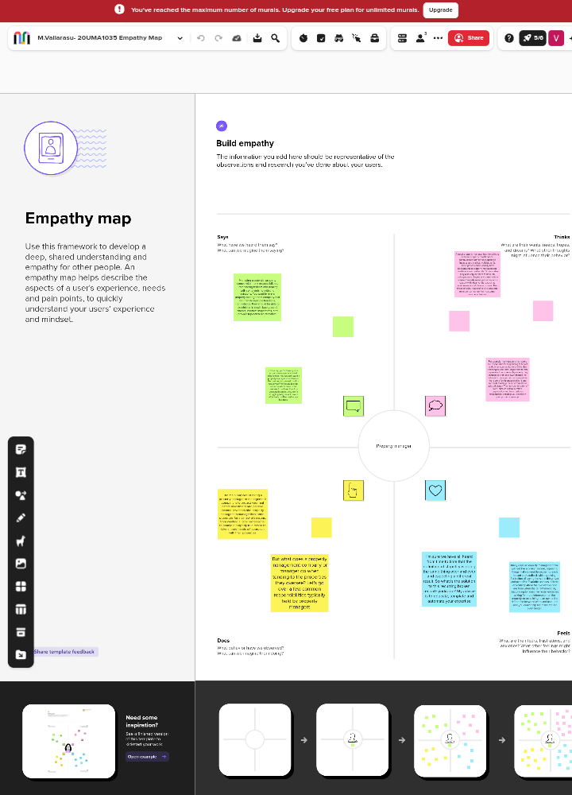

2.2 IDENTIFICATION & BRAINSTROMING MAP

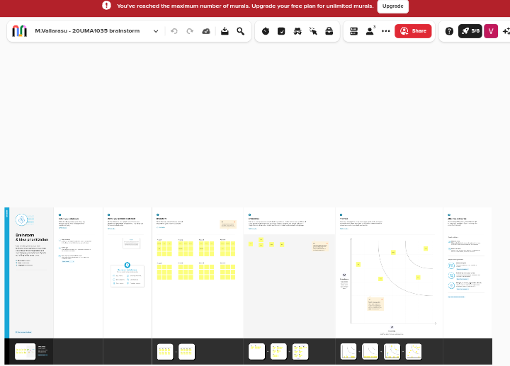

3. RESULT

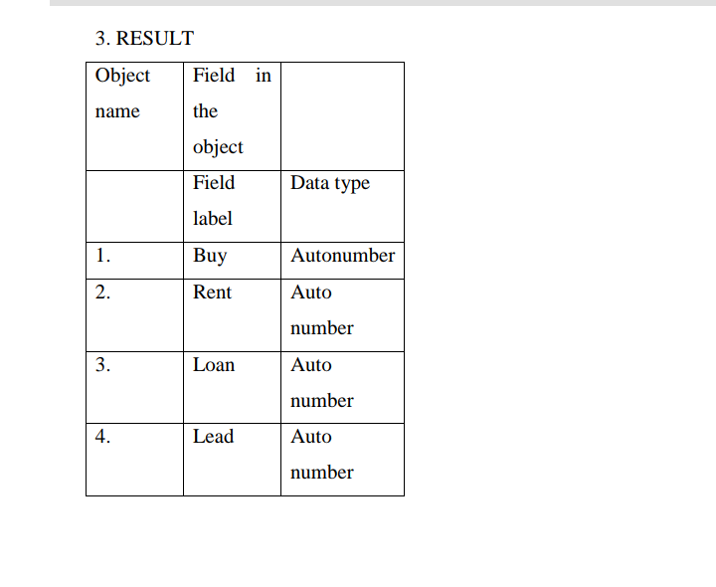

3.2 ACTIVITY AND SCREENSHOT

MILESTONE 1 – Salesforce

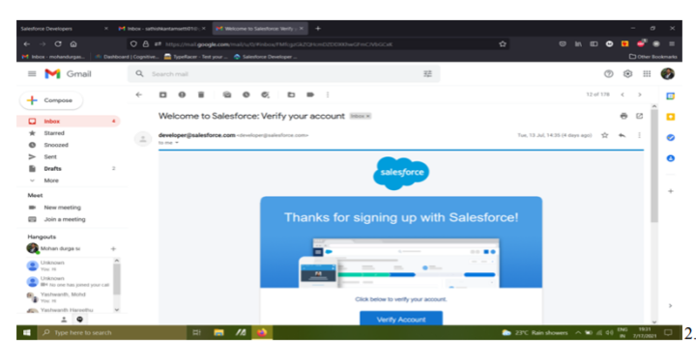

MILESTONE 2 - Object

Activity 1:

Create Object buy

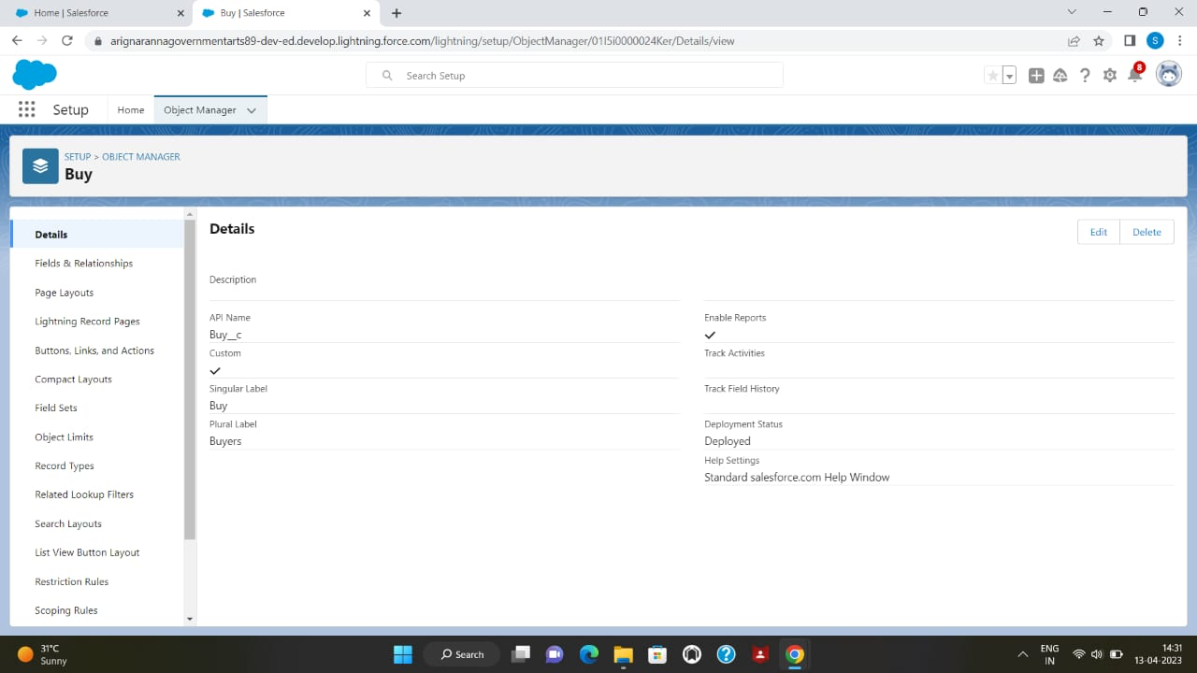

Activity 2: Rent

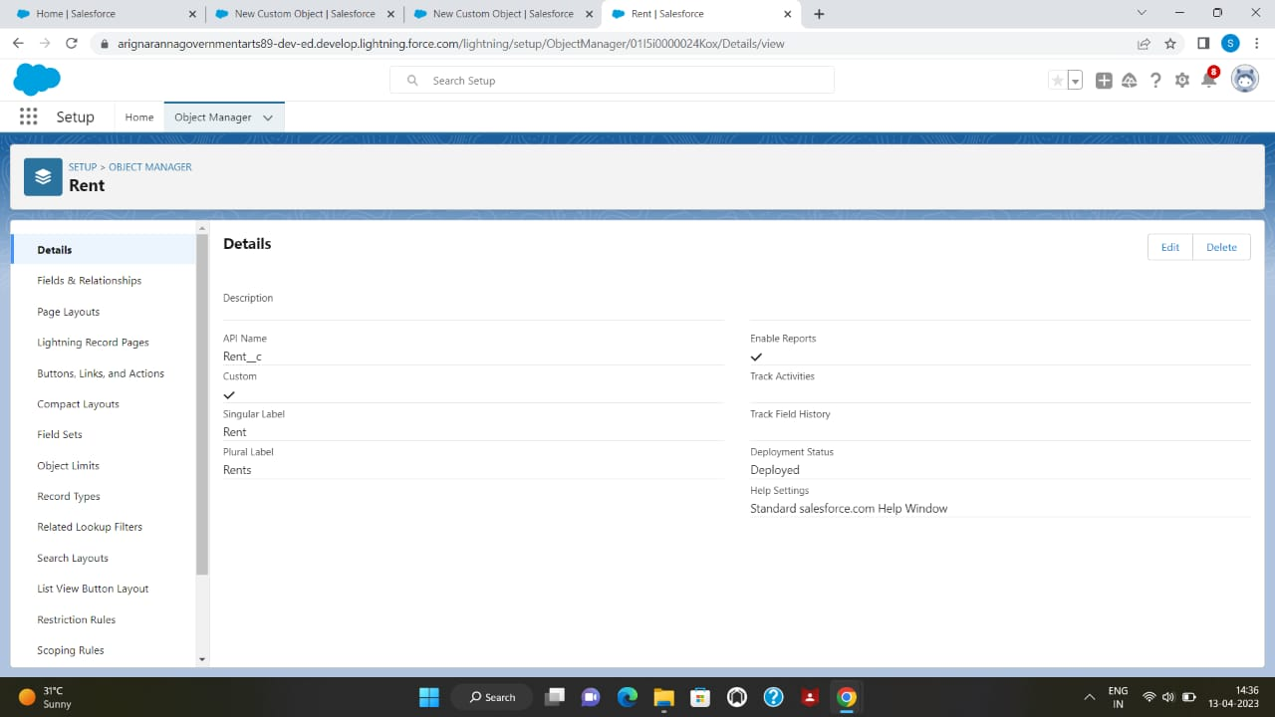

Activity 3: Loan

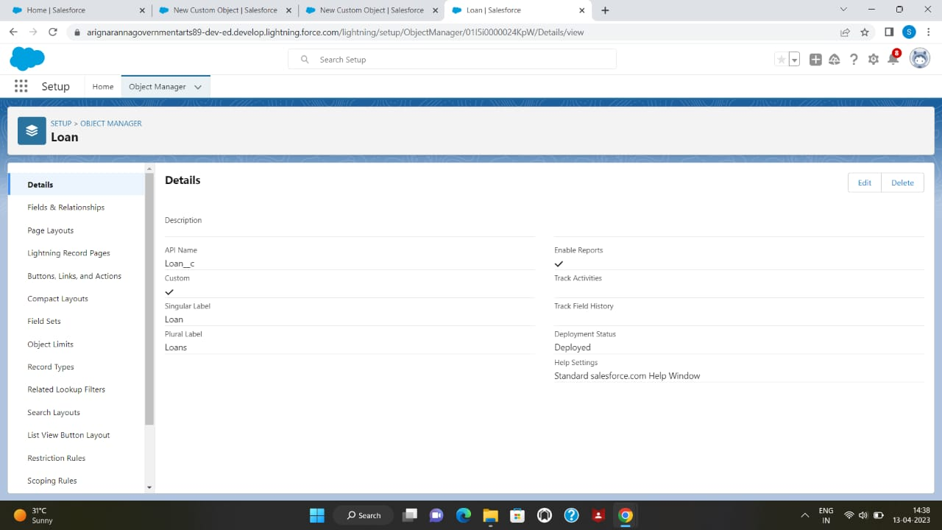

MILESTONE 3: Tab

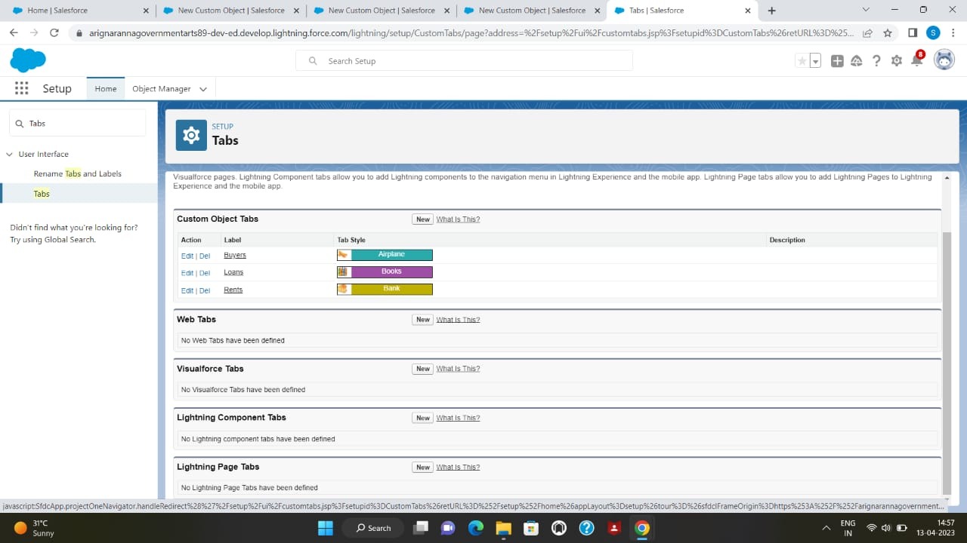

MILESTONE 4: The Lightning app

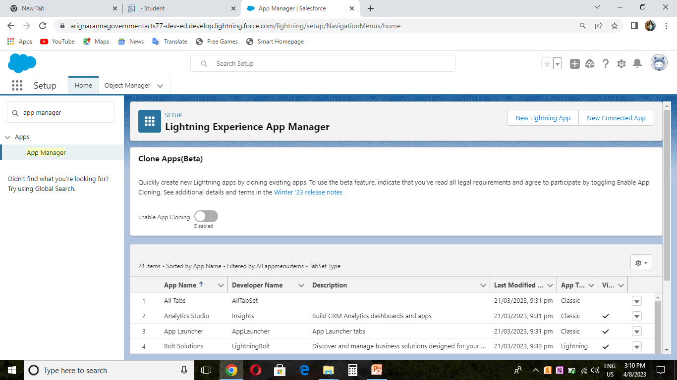

MILESTONE 5: Fields

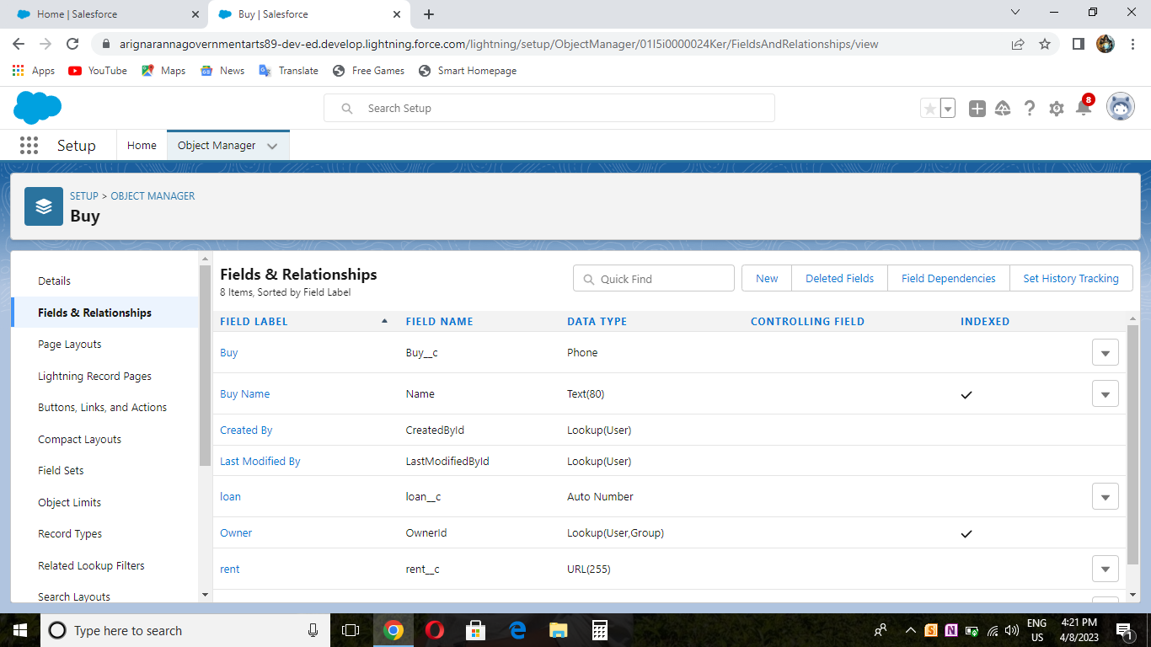

MILESTONE 6: Profile

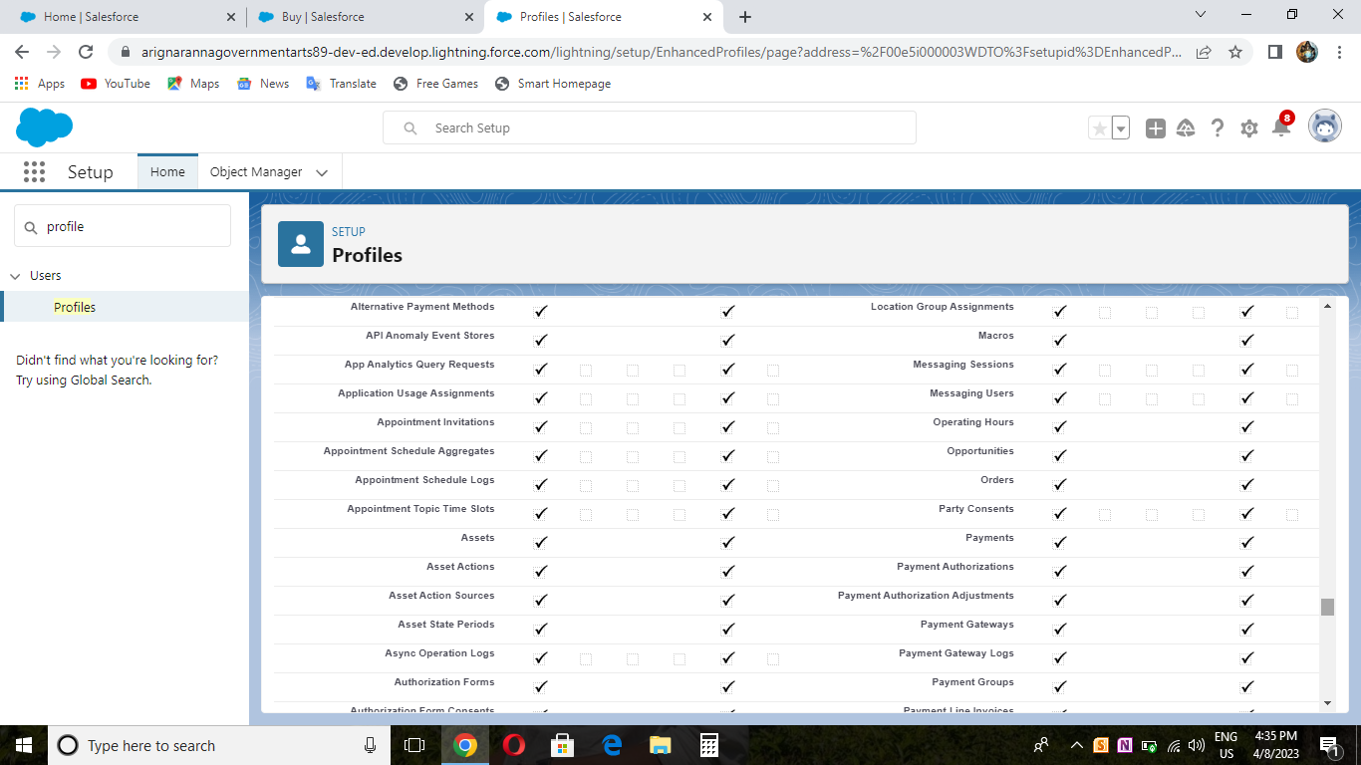

MILESTONE 7: New User

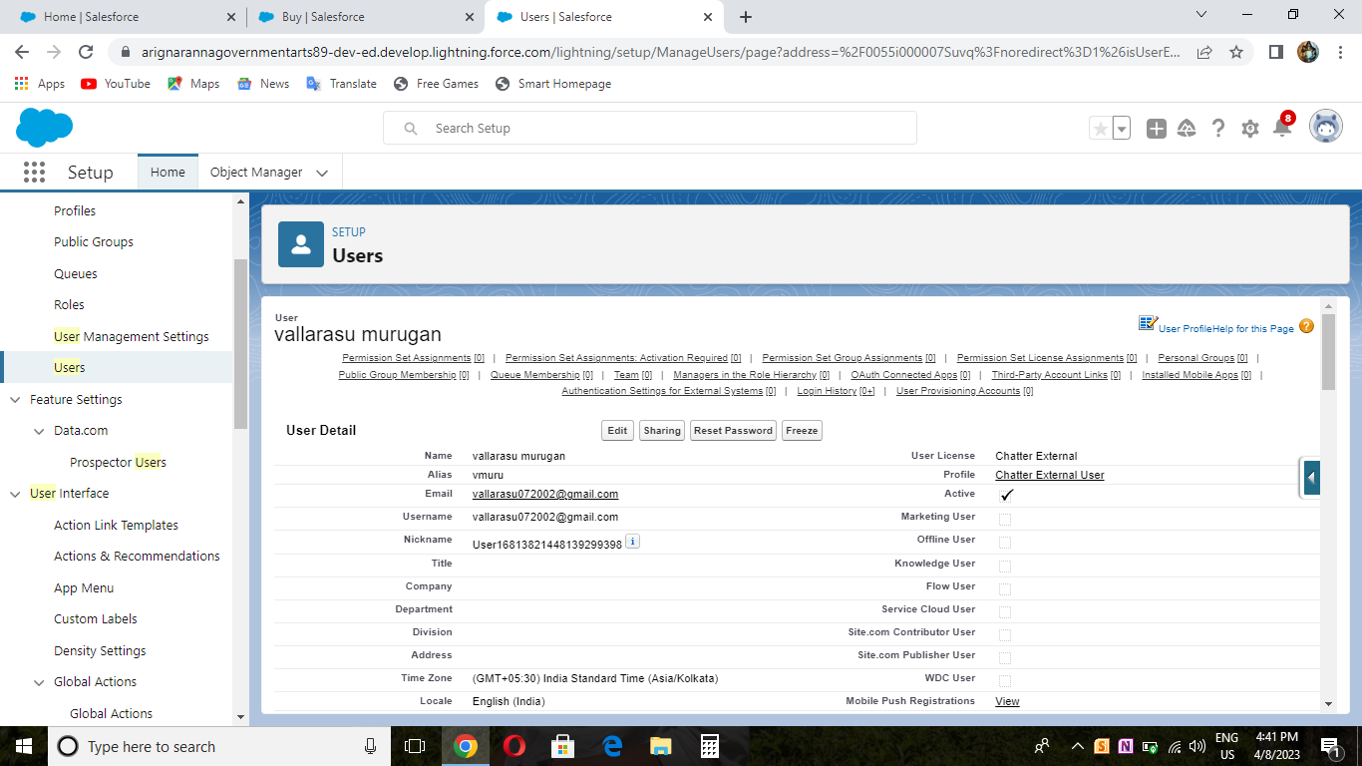

MILESTONE 8: Permission Set

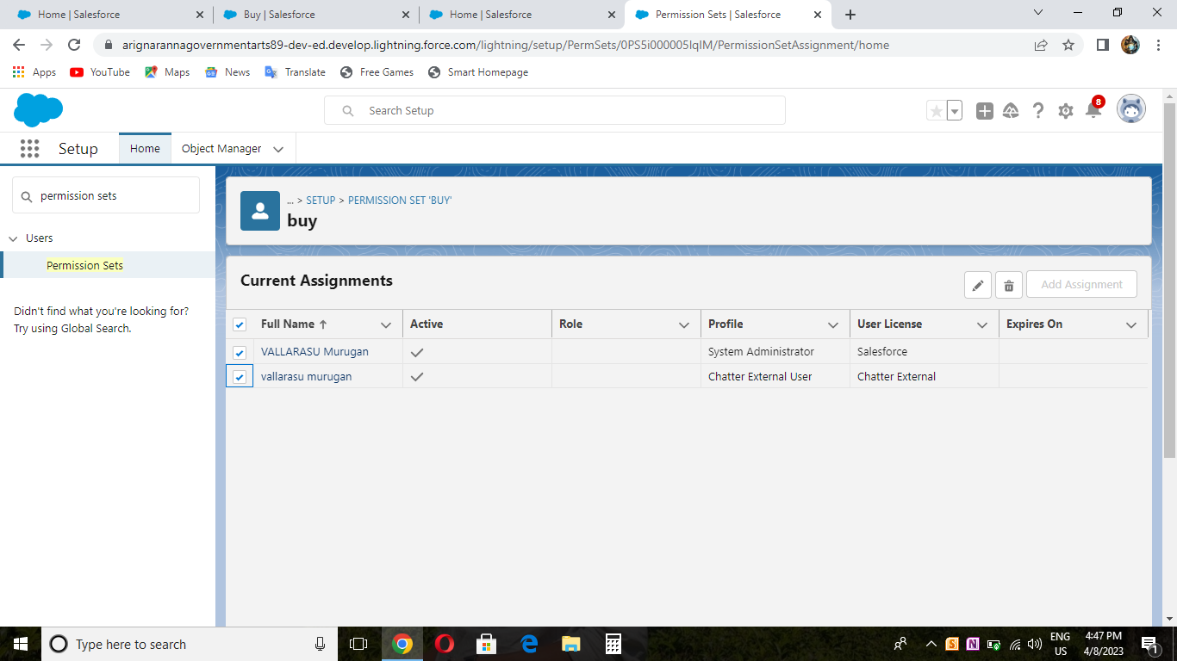

MILESTONE 9: Setup For OWD

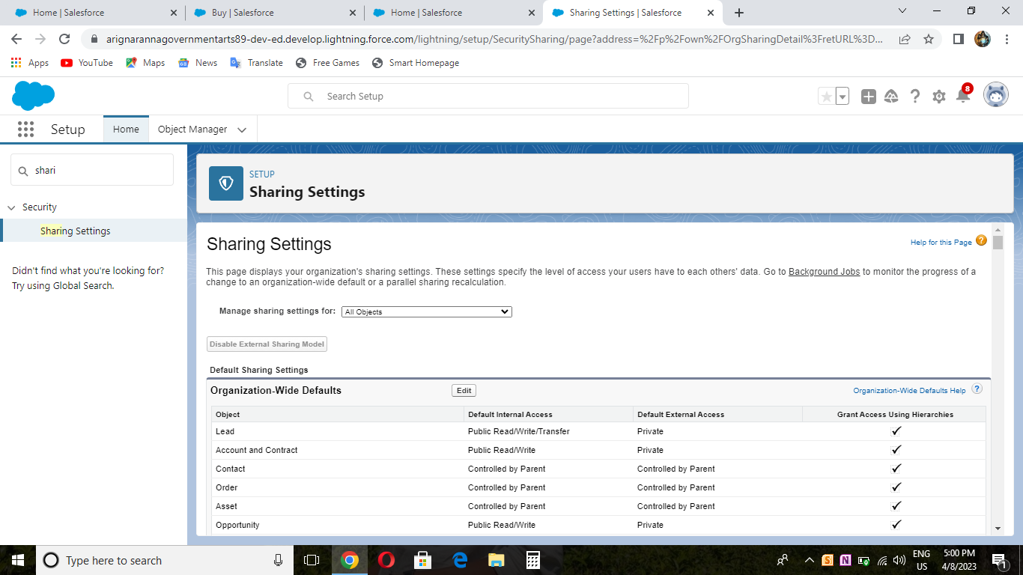

MILESTONE 10: Report

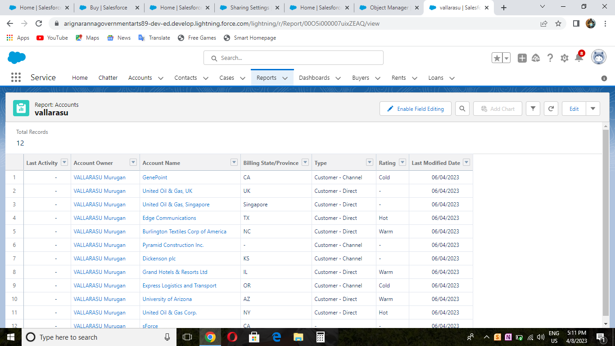

MILESTONE 11: Dashboards

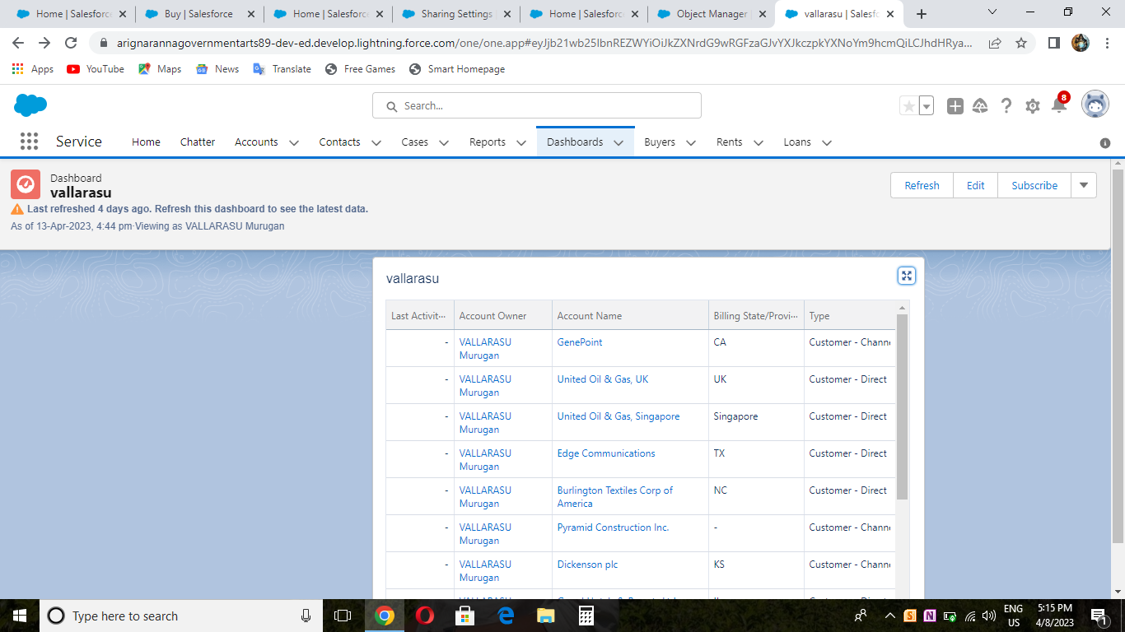

4. Trailhead URLs

Team leader - <https://trailblazer.me/id/vmurugan46>

Team member 1- <https://trailblazer.me/id/maraj125>

Team member 2 -<https://trailblazer.me/id/cprasanth7>

Team member 3-<https://trailblazer.me/id/sdurai50>

5. ADVANTAGE

• Easy maintenance monitoring.

• Easy payments from tenants and contractors.

• Data tracking.

• Property management.

• 24\*7 support & customer loyalty.

• Quick inspection.

• Tenant screening.

DISADVANTAGE

• Lack of specialists that have a deep understanding of property management business and

its priorities.

• Higher price if you look not only for technical skills but for industry expertise, especially

in specific niches like property management.

• PMS provides a suite of services that can help firms monitor and optimize back-office

activities and finances and even enhance the security of their properties. Additionally,

PMS enhances communication between tenants, owners, and managers, making it easier

for all parties to stay informed and connected in real time-consuming if you choose the

wrong system.

• Might seem expensive for a small business.

• Training (cost and time).

6. APPLICATION

A property management system (PMS) is a software application for the operations of hospitality

accommodations and commercial residential rental properties. PMS is also used in

manufacturing industries, local government and manufacturing.

➢ Lease collection.

➢ Lease adjustments.

➢ Property expense controls

➢ Property Project administration

➢ Generation of work orders

➢ Management and generation of common expenses (HOA expenses)

➢ Ticket requirement management of branches.

7.CONCLUSION

Property managers assist owners in creating budgets, advertise rental properties, qualify

tenants, and collect rent. They also comply with the local landlord and real estate board laws and

maintain the property.PMS provides a suite of services that can help firms monitor and optimize

back-office activities and finances and even enhance the security of their properties.

Additionally, PMS enhances communication between tenants, owners, and managers, making it

easier for all parties to stay informed and connected in real time.

The number one benefit of using a PMS is saving time. One of the biggest problems hoteliers

face is being time-poor. With a PMS, you'll reduce time spent on admin, increase time available

for backlogged tasks, and most importantly, free up time for yourself.

Property manager responsibilities include setting and collecting rent, handling maintenance

requests, filling vacant units and potentially setting the budget for the property. Property

managers often take care of property that real estate investors either do not live near or do not

wish to personally manage.

8. FUTURE SCOPE

Advanced automation takes real estate management into the future.With access to the

right data, property managers can improve their business and better connect with their tenants.

But checking reports and applying insights still takes time, and when you have a large number of

clients, that’s time you might not have — unless your real estate management software solution

incorporates advanced AI.Artificial intelligence (AI) picks up where more traditional automation

leaves off. For example, A.I. can incorporate data to build tenant emails, suggest next steps, and

find connections. And, with new advances in machine learning, property management AI. can

actually become smarter and more effective as it goes. If you want to provide your tenants with

the best possible service, having AI enhanced real estate management software can make a

significant difference, while also freeing you up to focus on what’s truly important: the

relationship not just the details.

Salesforce revolution real estate management.The rental industry is on the rise, and

property management is growing to meet it. Salesforce, already the world leader in CRM

technology, has long been used as a superior real estate management system, making CRM for

real estate a reality. And now, thanks to specialised applications built on the Salesforce Platform

and incorporating the most advanced AI available, you can use those tools to manage your data,

guide your tenants, and optimize your property management business.

Your renters need more than just shelter — they need a property manager they know they can

trust. With real estate management software from Salesforce, you can give your renters the

support they need. Contact Salesforce today and start building relationship.